Activity: Build a Paper Tower
Posted on September 20th, 2010 by ASEE
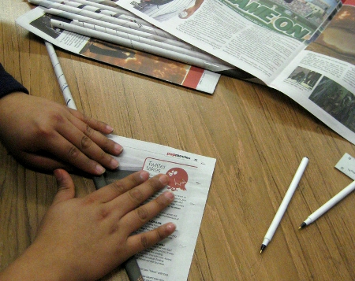
http://www.flickr.com/photos/vinzcha/ / CC BY 2.0
(Activity courtesy of PBS, Building Big: Skyscrapers) Time Required: Approximately 20 minutes. Group Size: 2-3 students

Overview:
Students are challenged to build the tallest structure they can using only two sheets of newspaper, getting it to stand up firmly without using tape, staples, glue, or other materials. By considering to bend, fold, or tear the paper, students learn about basic structural techniques in building creation.

Materials:
(per groups of two)
- 2 sheets of newspaper
- ruler
- hand wipes for cleanup
- scotch tape (for activity extension)

Vocabulary:
Force - any action that tends to maintain or alter the position of a structure
Load - weight distribution throughout a structure; loads caused by wind, earthquakes, and gravity affect how weight is distributed throughout a structure
Pressure - a force applied or distributed over an area
Spire - an architectural or decorative feature of a skyscraper; the Council on Tall Buildings and Urban Habitat includes spires, but not antennae, when calculating the official height of a skyscraper
Stable - (adj.) ability to resist collapse and deformation; stability (n.) characteristic of a structure that is able to carry a realistic load without collapsing or deforming significantly
Unstable - characteristic of a structure that collapses or deforms under a realistic load

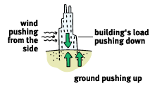
Background:
The strength of a building material can depend on how it is used. Pleating or rolling paper can increase its stiffness. By crumpling, folding, and otherwise reshaping the flimsy flat sheets and by forming a wide base, students can make their newspaper sheets in this activity stand up and reach unexpected heights
Many forces are at work on towers. Gravity and the dead load of a towers will push down, the ground pushes back up, and small air movements push from the side. A foundation distributes the load into the surrounding ground material and can help balance the sideways wind force. The size of the foundation depends on the strength of the supporting ground. A foundation placed in rock can be smaller than a foundation placed in sand or mud.

Procedure:
Introduce the Activity
- Hold up an index card and announce that you want to stand it up on a table; Ask students if they think you can do this — they will probably laugh and say no. Stand the card on one edge so that it falls over. Ask: Is there anything I can do to make this card stand up? Students may suggest changing the shape of the paper by folding it, curving it into a column, or tearing the bottom to make “feet.”
- Explain that the students’ challenge is to build the tallest structure they can using only two sheets of newspaper. They will need to get their towers to stand up without using tape, staples, glue, or other materials. Reminding them of the index card, encourage consideration of how they might bend, fold, or tear the paper.
- Before they begin, students could be asked to predict just how tall a tower they will be able to achieve. What is their prediction based upon?
Lead the Activity
Tell students:
- Before you begin, brainstorm all the ways you can alter the paper, keeping in shapes and stability. Getting ideas from other groups is okay; this is not a competition, but rather a chance to learn from others’ discoveries.
- Now, begin constructing your tower. Kep it stable, firmly planted on the desk or table top, but if you think you can make it even taller, keep redesigning until you can’t go any higher.
- When you are finished building, measure the height of your tower.

Assessment
After the groups finish and measure their towers, have everyone take a tour of the results.
- Ask: What forces are affecting these towers? Use one tower as a model to point out that gravity and the dead load of the tower are pushing down, the surface is pushing back up, and small air movements are adding forces from the side.
- Ask: What different solutions did groups come up with to counteract these forces? What is similar about the taller structures? Encourage students to point out creative uses of shapes, fastening techniques, wide bases, and other solutions to balancing and stiffening the towers.
- Ask: How did your result compare to your prediction? Give possible reasons for any difference. What limited the height of your tower? If you could use one other material to make your tower taller, what would it be? Why?
Extensions
- Vary the activity
  - How much taller can students make their tower if they can add 8 inches of tape? They can’t use the tape to secure the tower to the table; so, how can they use it? After you allow time to discuss and explore uses of the tape, suggest that it could help stiffen the newspaper, particularly at the base, or could hold stable shapes such as triangles or columns together.
  - How tall can they make the tower and have it support the weight of a pack of chewing gum?
- Testing stability
How well does each tower withstand environmental forces? Use a fan to imitate wind gusts or shake the table gently to imitate an earthquake. How would the students alter their initial designs, to better withstand such forces? How could they do so, using 2 sheets of newspaper and 8 inches of tape?
- Lead a discussion
Discuss the difference between dead load (the weight of the tower itself) and live load (the weight of a golf ball).
- Make Connections.
Have students compare how well they can balance with their feet together and apart. (Apart is more stable.) Brainstorm things that have wide bases for stability (snowshoes, skis, traffic cones). What spacing between their feet feels most stable? How can kids apply this knowledge in basketball, wrestling, or gymnastics?
- Video Connection The “San Gimignano” episode from the PBS Skyscrapers video to explain the basic forces acting on a tower and the importance of foundations. (Check the Program Description to locate the show segment.)
Try the Loads Lab.
For more information, see Additional Resources.

Online Resources
PBS Building Big: All About Skyscrapers contains online information, links and activities focused on tall structures, building concepts, and profiles of two structural engineers.
Duke University’s Center for Inquiry-Based Learning offers a similar activity, with more extensive evaluation and writing exercises.

